Skewness

Skewness is a way of estimating and measuring the shape of a distribution. It is a vital statistical method for estimating asymmetrical behavior rather than computing the frequency distribution. Its value can be either positive or negative.

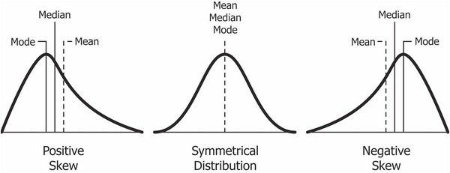

A positive skew will indicate that the tail is on the right side. It will extend toward the most positive values.  
On the other hand, a negative skew will indicate a tail on the left side and will extend to the more negative side.  
A zero value will indicate that there is no skewness in the distribution, which means that the distribution is perfectly symmetrical.

The distribution of skewness values is as below:

* Skewness = 0 when the distribution is normal.
* Skewness > 0 or positive when more weight is on the left side of the distribution.
* Skewness < 0 or negative when more weight is on the right side of the distribution.

## Kurtosis

Kurtosis is a statistical term that characterizes frequency distribution. Aside from determining if a distribution is heavy-tailed, it also provides insight into the shape of the frequency distribution.

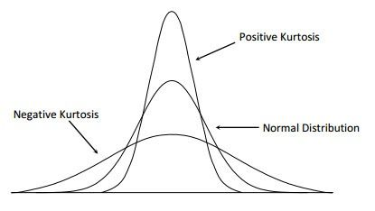

Kurtosis of a normal distribution is equal to 3. When the kurtosis is less than 3, it is known as platykurtic, and when it is greater than 3, it is leptokurtic. If it is leptokurtic, it will signify that it produces outliers rather than a normal distribution.